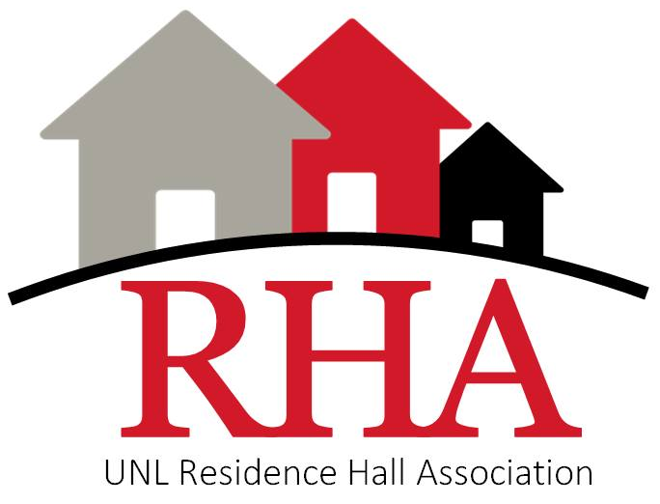

49th Senate
SB XX

Residence Hall Association
University of Nebraska-Lincoln

SB XX: Title of Senate Bill
_______________________________________________________
Submitted by: Senator XXX on behalf of XXX
Submission Date: XX/XX/XXXX
¯¯¯¯¯¯¯¯¯¯¯¯¯¯¯¯¯¯¯¯¯¯¯¯¯¯¯¯¯¯¯¯¯¯¯¯¯¯¯¯¯¯¯¯¯¯¯¯¯¯¯¯¯¯¯
- Whereas the writing of bills is key to much of the business of RHA meetings, so RHA has therefore adopted a set of procedures for writing bills; and,
- Whereas these procedures involve using a series of whereas clauses that are logically connected in order to provide evidence and backing for a course of action; and,
- Whereas any number of whereas clauses may be used, but there are typically at least three and may be as many as necessary to support the bill; and,
- Whereas whereas clauses should be written in complete sentences, but each clause should close using “; and,” to ensure flow between clauses,
- Be it therefore enacted that the Residence Hall Association requests that some course of action be taken; in this case, that all RHA members utilize this format for the writing of all bills to be brought before the body; and,
- Be it further enacted that RHA also recommends that members new and old use this template to write their legislation in order to save them from the time and effort of retyping it each time they write legislation; and,
- Be it further enacted that all bills must include the following mandatory “be it further enacted” statements with the exception of the final statement of this bill; and,
- Be it further enacted that all funds and other support from RHA will be subject to the RHA Funding Guidelines, which can be found on the RHA website; and,
- Be it further enacted that all unused monies be returned to RHA to the __________ budget line; and,
- Be it further enacted that the RHA banner will be displayed at the event; and,
- Be it further enacted that the RHA logo will be placed on all advertisements; and,
- Be it further enacted that an OTM be submitted for the event; and,
- Be it further enacted that all marketing materials for the program contain the following statement: If reasonable accommodations such as interpreters, large print, special seating, etc. are needed to accommodate a disability, please contact {Event Host} at {Telephone Number} or {Email Address} to discuss accommodations at least one week prior to {Event} to ensure we can make appropriate arrangements
- Be it further enacted that bills should be submitted to the Speaker of the Senate on the RHA website through the senator “submit a bill” webform.
_______________________________________________________

Floor Action: ___________________________________

President's Signature: ___________________________________
¯¯¯¯¯¯¯¯¯¯¯¯¯¯¯¯¯¯¯¯¯¯¯¯¯¯¯¯¯¯¯¯¯¯¯¯¯¯¯¯¯¯¯¯¯¯¯¯¯¯¯¯¯¯¯

